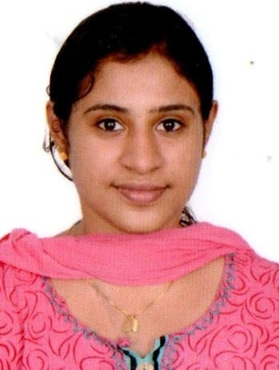
Dr.Lakshmi.P.Das
BDS, MDS, Snr lecturer,
Dept. Oralpathology & Microbiology
Sreesankara Dental College Varkala,Trivandrum

Publications details
1. Concept of stem cells and it's importance in dentistry - A Review
Dr.lakshmi.P.Das,Dr.Neema balan,Dr.Nitheash.P, Dr. Bastian T S, Dr. Selvamani.M, Dr. Maria Bobby Cyriac.
2. Role of oral halitosis
Dr.Neema balan,Dr.Lakshmi.P.Das,Dr.Selvamani.M,Dr. Bastian T.S,Dr.Lakshmi.P.Das
BDS, MDS, Snr lecturer,
Dept. Oralpathology & Microbiology
Sreesankara Dental College Varkala,Trivandrum

Publications details
1. Concept of stem cells and it's importance in dentistry - A Review
Dr.lakshmi.P.Das,Dr.Neema balan,Dr.Nitheash.P, Dr. Bastian T S, Dr. Selvamani.M, Dr. Maria Bobby Cyriac.
2. Role of oral halitosis
Dr.Neema balan,Dr.Lakshmi.P.Das,Dr.Selvamani.M,Dr. Bastian T.S,

