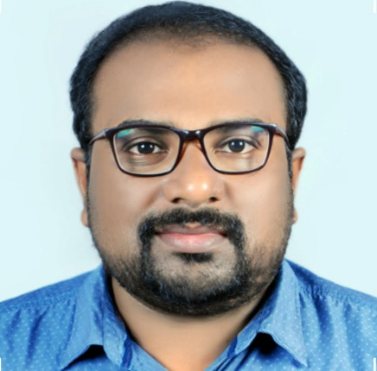

Name:: Dr.Praveen D

Qualification: MDS

Designation: Head of the Department & Associate Professor
Dept.of Public Health Dentistry

Awards &; Achievements:

Guided for the Best Innovative Health Education model for the UG students at 9th Kerala State Conference of Indian Association of Public Health Dentistry (IAPHD)

Participated as a Resource Person for IDA Kasaragod Branch for delivering a lecture on
'Anti Tobacco Awareness program' held at Kasaragod Sub Jail on July 2016.

PUBLICATIONS

1. Oral Health Status of Institutionalized Leprosy Patients in Kerala. Indian J Lepr. 2018;90:23-34.

2. Antimicrobial Effect of Ginger, Garlic, Honey, and Lemon Extracts on Streptococcus
mutans. J Contemp Dent Pract 2017;18(11):1004-1008.

3. Relationship Between Obesity and Periodontitis in 20-50 Year Old Adults of South Canara,India. Int J Sci Stud 2014;2(5):11-14

4. A descriptive assessment of oral hygiene and salivary parameters among identical and non-identical twins. December 2015 Journal of Research in Dentistry 3(3):711-720

5. Patterns of dental problems and time gap in utilization of dental services by patients visiting a dental college in North Kerala. SRM J Res Dent Sci 2019;10:130-4.

6. Smartphone usage among female students of a private dental institution in North Kerala: A cross-sectional study. J Dent Res Rev 2019;6:83-7.

7. Perception, comprehension and Cognizance of dental Insurance – A cross sectional study
Amid Keralites. International Journal Dental and Medical Sciences Research. 2022; 4(4): 587-592.

8. Self-perception, Knowledge and Attitude about Halitosis Among Young Adults. A cross
sectional Questionnaire study. International Journal Dental and Medical Sciences Research.2022; 4(4): 654-2022; 4(4): 654-665

9. Awareness and knowledge about RCT treatment among Keralites: A cross sectional
Questionnaire based study. International Journal Dental and Medical Sciences Research. 2022; 4(5): 109-115

10. Association of maternal and neo natal nutrition with dental development in children.
International Journal Dental and Medical Sciences Research. 2023; 5(1): 330-351

11. Oral health & oral health behaviour in young adults with caries disease. International Journal Dental and Medical Sciences Research. 2023; 5(1): 442-446

12. Factors influencing the selection of toothpaste and toothbrush among outpatients of Sri Sankara Dental College, Trivandrum. International Journal Dental and Medical Sciences Research. 2023; 5(1): 417-427

13. Effectiveness of two different oral health education methods on oral hygiene status of
orthodontic patients. International Journal of Advances in Engineering and Management. 2023; 5(1): 928-933.

14. Assessment of parental care on Oral health of children with special needs in Trivandrum district. International Journal Dental and Medical Sciences Research. 2023; 5(1): 389-400

15. Knowledge, awareness about dental flossing among young adult population in Kerala. International Journal Dental and Medical Sciences Research. 2023; 5(1): 460-471

16. Effects of wearing masks during pandemic on oral hygiene practices, oral conditions,
esthetic concern and dental care in Keralites. International Invention of Scientific Journal.
2023; 7(01): 12-20.

17. Evaluation of stress and anxiety among undergraduate students from different education streams of Trivandrum district. International Journal Dental and Medical Sciences Research.2023; 5(1): 442-446

18. Knowledge and attitude among adults towards advertisements related to dental products –A cross sectional study amid Keralites. JOADMS. 2023; 9(1): 12-26.

19. Dental aesthetics and its impact on psychological wellbeing among students of dental colleges in South Kerala. International Journal Dental and Medical Sciences Research. 2023;5(1): 378-388

As a contributing author for Textbook

1.Essentials of Orthodontics; 2018 ISBN No: 978-93-86480-26-2 Paras Medical Books, Hyderabad.

